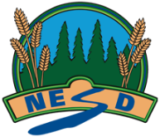 Module 34B: Agricultural Business (Optional): Name: ___________________

 | Fully meeting expectations, with enriched understanding (EU) | Fully meeting grade level expectations (FM) | Mostly meeting grade level expectations (MM) | Not yet meeting grade level expectations (NY)
Examine business ownership as applied to agricultural industry. | You can confidently examine business ownership as applied to agricultural industry.  You might be: | You can examine business ownership as applied to agricultural industry.  You show this by:  You support your examination with relevant details and examples. | You are exploring and practicing examining business ownership as applied to agricultural industry.  You may be: | You are having trouble examining business ownership as applied to agricultural industry.  Consider:
Feedback:

